The Whittle-le-Woods Curriculum
Whatever you do, work at it with all your heart. Colossians 3:23
Maths
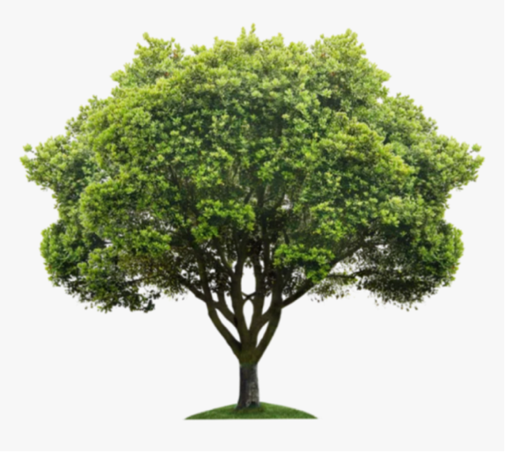
Curiosity
Skills
Knowledge
Wisdom
Courageous Advocates
Rooted in Christ and flourishing
Reflective
Reciprocal
Resilient
Resourceful

Our Maths curriculum at Whittle-le-Woods aims to:
Enable children to serve others courageously by understanding that there may be many ways to solve a maths problem and sharing ideas enables all children to develop their mathematical ability. Children will be excited and curious about seeing maths in the real world and develop communication skills where they use wisdom to explain concepts. Children’s talents will soar as they understand the requirements for strong mathematical understanding and use courage to continue when difficulties arise.
 | Aut 1 |  |  | Aut 2 |  |  |  | Spring 1 |  |  |  |  |  | Spring 2 |  |  |  | Summer 1 |  | Summer 2
Nursery | Number songs  Colours  Match  Sort  What do you notice? |  |  | Number 1  Number 2  Patterns  Consolidation |  |  |  | Number 3 - (2 weeks)  Number 4 - (2 weeks)  Number 5 - (2 weeks) |  |  |  |  |  | Consolidate 1-5  Number 6  Height and length  Mass  Capacity  Consolidation |  |  |  | More than/fewer than  One more  One less  Shape (2 weeks)  Consolidation |  | Number composition 1-5  Night and day  Positional language (2 weeks)  Consolidation
Reception | Weeks 1 and 2 - Getting to know you  Weeks 3 and 4 – Match, sort and compare  Weeks 5 and 6 – Talk about measure and patterns |  |  | Weeks 7 and 8 – It’s me 1,2,3  Week 9 – Circles and triangles  Weeks 10 and 11 – 1,2,3,4,5  Week 12 – Shapes with 4 sides |  |  |  | Weeks 1 and 2 – Alive in 5  Week 3 – Mass and capacity  Weeks 4 and 5 – Growing 6,7, 8 |  |  |  |  |  | Weeks 6 and 7 – Length, height and time  Weeks 8 -10 – Budling 9 and 10  Weeks 11 and 12 – Explore 3D shapes |  |  |  | Weeks 1 and 2 – To 20 and beyond  Week 3 – How many now?  Weeks 4 and 5 – Manipulate, compose and decompose  Weeks 6 and 7 - |  |  | Weeks 8 - 10 – Visualise, build and map  Week 11 – Make connections  Week 12 – Consolidation  Revisiting and consolidation
Y1 | Numbers to 10 Number bonds | Addition/Subtraction within 10 | Positions | Numbers to 20 | Addition & subtraction within 20 |  | Shapes & Patterns | Length & Height | Numbers to 40 |  | Addition & Subtraction word problems |  |  | Multiplication  Division | Fractions | Numbers to 100 |  | Time | Money | Volume & Capacity |  | Mass | Revision & review
Y2 | Numbers to 100 | Addition and Subtraction |  | Multiplication of 2, 5 and 10  & division | Length  Mass  Temperature |  |  | Pictograms | Worded problems - money |  | 2D shapes |  |  | 3D shapes | Fractions |  |  | Time | Volume | Revision Number & Place Value |  | Revision: 4 operations | Revision of weaker areas
Year 3 | Numbers to 1000 | Addition and subtraction |  | Multiplication and division | Further Multiplication and division |  |  | Length | Mass |  | Volume |  |  | Geometry: Lines & shapes | Time | Picture graphs & Bar graphs |  | Fractions |  | Angles |  | Money | Perimeter of figures
Year 4 | Numbers to 10 000 | Addition and subtraction within 10 000 |  | Multiplication and division | Further multiplication and division |  | Graphs | Fractions | Time |  | Decimals |  |  | Geometry | Mass, volume and length |  |  | Area of figures | Money | Position and movement |  | Roman Numerals
Year 5 | Place Value | Number:- Addition and Subtraction |  | Multiplication & division |  | Fractions A |  | Multiplication & division |  |  | Fractions |  | Decimals & % |  | Geometry: Position & direction |  | Statistics | Geometry: Properties of shape | Measure: Area &perimeter | Decimals |  | Negatives  & Converting Units | Geometry: Volume
Year 6 | Place Value | Calculating 4 operations  Number Facts  Primes, Factors, multiples |  | Properties of 2d  And 3d shapes | Handling Data |  | Efficient calculating method | Identifying relationships FDP |  | Properties & classifying 2d & 3D shapes |  | Pie charts & Conversions |  | Ratio & Averages | Algebra | Coordinates,Reflections, Translations |  | Revision of all maths objectives |  | Business skills relating to economics  Life skills eg budgeting, change, offers, etc  Scale through art

Nursery

Autumn 1 | Number songs | Colours |  |  |  | Match |  | Sort
Autumn 1 | Opportunities for settling in, introducing the areas of provision and getting to know the children. | Children should be taught to recognise and name colours in a variety of contexts e.g. toys within the classroom, colours in nature, colours in the environment, matching colours, colours on themselves such as hair, skin, clothes. Children should be able to say when objects are and are not the same colour. Link to expressive art and design through painting. |  |  |  | Provide opportunities for the children to explore and match objects which are the same.  Can you find one exactly like mine? How do you know it’s the same? Can you find one different to mine? Why is this one not like mine? |  | Children learn that collections can be sorted into sets based on attributes such as colour, size or shape.  Sorting enables the children to consider what is the same about all the objects in one set and how they are different to the other sets.  They begin to understand that the same collection of objects can be sorted in different ways
Autumn 2 | Compare amounts |  |  | Compare size, mass, capacity |  |  | Simple patterns
Autumn 2 | Once children can confidently sort collections into sets they learn that these sets can be compared and ordered. They understand that when making comparisons a set can have more, the same or fewer than another set. NOTE – it is easier for children to notice the difference between sets when the difference is greater.  Start by asking the children to compare 2 and 5 rather than 5 and 6 |  |  | Children learn that objects can be compared and ordered according to their size.  Encourage the use of language such as big and little, small and large to describe a range of objects.  More specific language such as tall, long, short can also be introduced. |  |  | Children copy, continue and create their own patterns.  It is important to provide patterns with at least three full units of repeat.  Encourage the children to say the pattern out loud
Spring 1 | Knowing Number 1 | Weight |  |  |  |  | Knowing Number 2
Spring 1 | Children identify representations of 1, 2, 3. They subitise or count to find out how many and make their own collections of 1, 2 or 3 objects.  They match the number names to quantities and numerals.  They touch count in different arrangements and recognise the final number is the quantity of the set.  Number blocks episode 1  Counting to 1  Finding 1 object  Representing 1 on a 5 frame  A circle – 1 sides shape (including in the environment)  1 action e.g. 1 hop, 1 jump, 1 clap  What is 1 made of 1 nose, 1 mouth, 1 body  Exploring different varieties of circles  1 being the first number, its position on a number line, ordinal numbers  Numicon 1  Dice 1  Subitising 1  The numeral and formation of 1  Number 1 in the environment  Representing 1 using marks, pictures and finger  Matching numeral to quantity |  | Children may already have experience of weight through carrying heavy and light items.  Encourage them to make direct comparisons holding items to estimate which feels the heaviest then use the balance scales to check.  Prompt them to use the language heavy, heavier than, heaviest, light, lighter than, lightest to compare items starting with items that have an obvious difference in weight.  Avoid common misconception that bigger items are always heavier by providing some small heavier items and some large lighter ones  heavy, heavier than, heaviest, light, lighter than, lightest |  |  |  | Children identify representations of 1, 2, 3. They subitise or count to find out how many and make their own collections of 1, 2 or 3 objects.  They match the number names to quantities and numerals.  They touch count in different arrangements and recognise the final number is the quantity of the set.  Number blocks episode 2  Counting to 2  Finding 2 objects  Representing 2 on a 5 frame  A semi circle – 2 sides shape (including in the environment)  2 actions e.g. 2 hops, 2 jumps, 2 claps  What 2 is made of 1 is a part of me, 1 is a part of me and the whole of me is 2  2 being the second number, its position on a number line, ordinal numbers  Numicon 2  Dice 2  Subitising 2  The numeral and formation of 2  Number 2 in the environment  Representing 2 using marks, pictures and finger  Matching numeral to quantity
Spring 2 | Knowing Number 3 |  | Length and height |  |  |  | Knowing Number 4
Spring 2 | Children identify representations of 1, 2, 3. They subitise or count to find out how many and make their own collections of 1, 2 or 3 objects.  They match the number names to quantities and numerals.  They touch count in different arrangements and recognise the final number is the quantity of the set.  Number blocks episode 3  Counting to 3  Finding 3 objects  Representing 3 on a 5 frame  A triangle – 3 sides shape (including in the environment)  3 actions e.g. 3 hops, 3 jumps, 3 claps  What is 3 made of - 2 is a part of me, 1 is a part of me and the whole of me is 3.  Exploring different varieties and orientations of triangles.  3 being the third number, its position on a number line, ordinal numbers  Numicon 3  Dice 3  Subitising 3  The numeral and formation of 3  Number 3 in the environment  Representing 3 using marks, pictures and finger  Matching numeral to quantity |  | Children begin by using language to describe length and height e.g. the tree is tall the pencil is short.  When making direct comparisons they may initially say something is bigger than something else. Encourage them to use more specific mathematical vocabulary in relation to  Length - longer, shorter  height – taller, shorter  Breadth – wider, narrower  The children should then move on to finding objects that are longer/shorter than a given item. They should be encouraged to utilise strategies such as direct comparison (e.g. placing objects side by side to determine which is longer).  Encourage them to use more specific mathematical vocabulary in relation to  Length - longer, shorter  height – taller, shorter  Breadth – wider, narrower |  |  |  | Children count on and back to 4.  They subitise sets of up to 4 objects to find out how many make their own collections of objects.  They match the number to numerals and quantities and are able to say which sets have more and fewer items.  When counting they continue to learn that the final number they say names the set.  Number blocks episode 4  Counting to 4  Finding 4 objects  Representing 4 on a 5 frame  Squares and rectangles, 4 sided shapes including in the environment  4 actions e.g. 4 hops, 4 jumps, 4 claps  Composition of 4 (2 is a part of me, 2 is a part of me and the whole of me is 4; 3 is a part of me, 1 is a part of me and the whole of me is 4)  4 being the fourth number, its position on a number line, ordinal numbers  Numicon 4  Dice 4  Subitising 4  The numeral and formation of 4  Number 4 in the environment  Representing 4 using marks, pictures and finger  Matching numeral to quantity
Summer 1 | Knowing Number 5 |  |  |  | 1 more 1 less |  | Shapes
Summer 1 | Children continue to subitise up to 5 items and to count forwards and backwards to 5 accurately using the counting principles.  They represent up to 5 items on a five frame.  Number blocks episode 5  Counting to 5  Finding 5 objects  Representing 5 on a 5 frame  Pentagons, 5 sided shapes including in the environment  5 actions e.g. 5 hops, 5 jumps, 5 claps  Composition of 5 (3 is a part of me, 2 is a part of me and the whole of me is 5; 4 is a part of me, 1 is a part of me and the whole of me is 5)  5 being the fifth number, its position on a number line, ordinal numbers  Numicon 5  Dice 5  Subitising 5  The numeral and formation of 5  Number 5 in the environment  Representing 5 using marks, pictures and finger  Matching numeral to quantity |  |  |  | The children will use real objects to see that the quantity of a group can be changed by adding more. The first, then, now structure can be used to create mathematical stories in meaningful contexts.  Children continue to count, subitise and compare as they explore one more and one less.  Prompt children to see the link between counting forwards and the one more pattern and back and the one less pattern. |  | The primary focus in relation shapes should be on the properties of shapes.  For example, children should be encouraged to notice and describe shapes in the environment and talk about the properties using words such as ‘straight/flat/round/ curved’.  When teaching the names of shapes, wherever possible, real life shapes in the environment should be used.  Note that only flat surfaces should be referred to as faces. Include sorting of natural shapes; the children may sort stones, for example, into sets that have straight edges, sets that have curved edges etc.
Summer 2 | My Day | Capacity |  |  |  |  | Positional language
Summer 2 | Children talk about night and day and order key events in their daily routines, such as waking up, coming to school, dinner, bed time.  They use language to describe when things happen e.g. day, night, morning, afternoon, before after, today, tomorrow.  Encourage the vocabulary of first, next, then and possibly last.  Children explore measuring time | Encourage children to build on their understanding of full and empty  Provide opportunities to explore capacity with different materials such as water, sand, rice and loose parts  Initially children should be exposed to the comparison of full, half full, empty using the same container.  Provide different sized and shaped containers to investigate,  When comparing capacities directly children can pour from one container to another to find which holds more or less water. |  |  |  |  | Children need opportunities to be exposed to and to use the language of position and direction; Position: ‘in’, ‘on’, ‘under’. Direction: ‘up’, ‘down’, ‘across’  Children also need opportunities to use terms which are relative: ‘in front of, ‘behind’, ‘on top of’.  Create as many opportunities as possible to explore this language such as hunting for hidden objects with some prompts (e.g. look behind the shed).

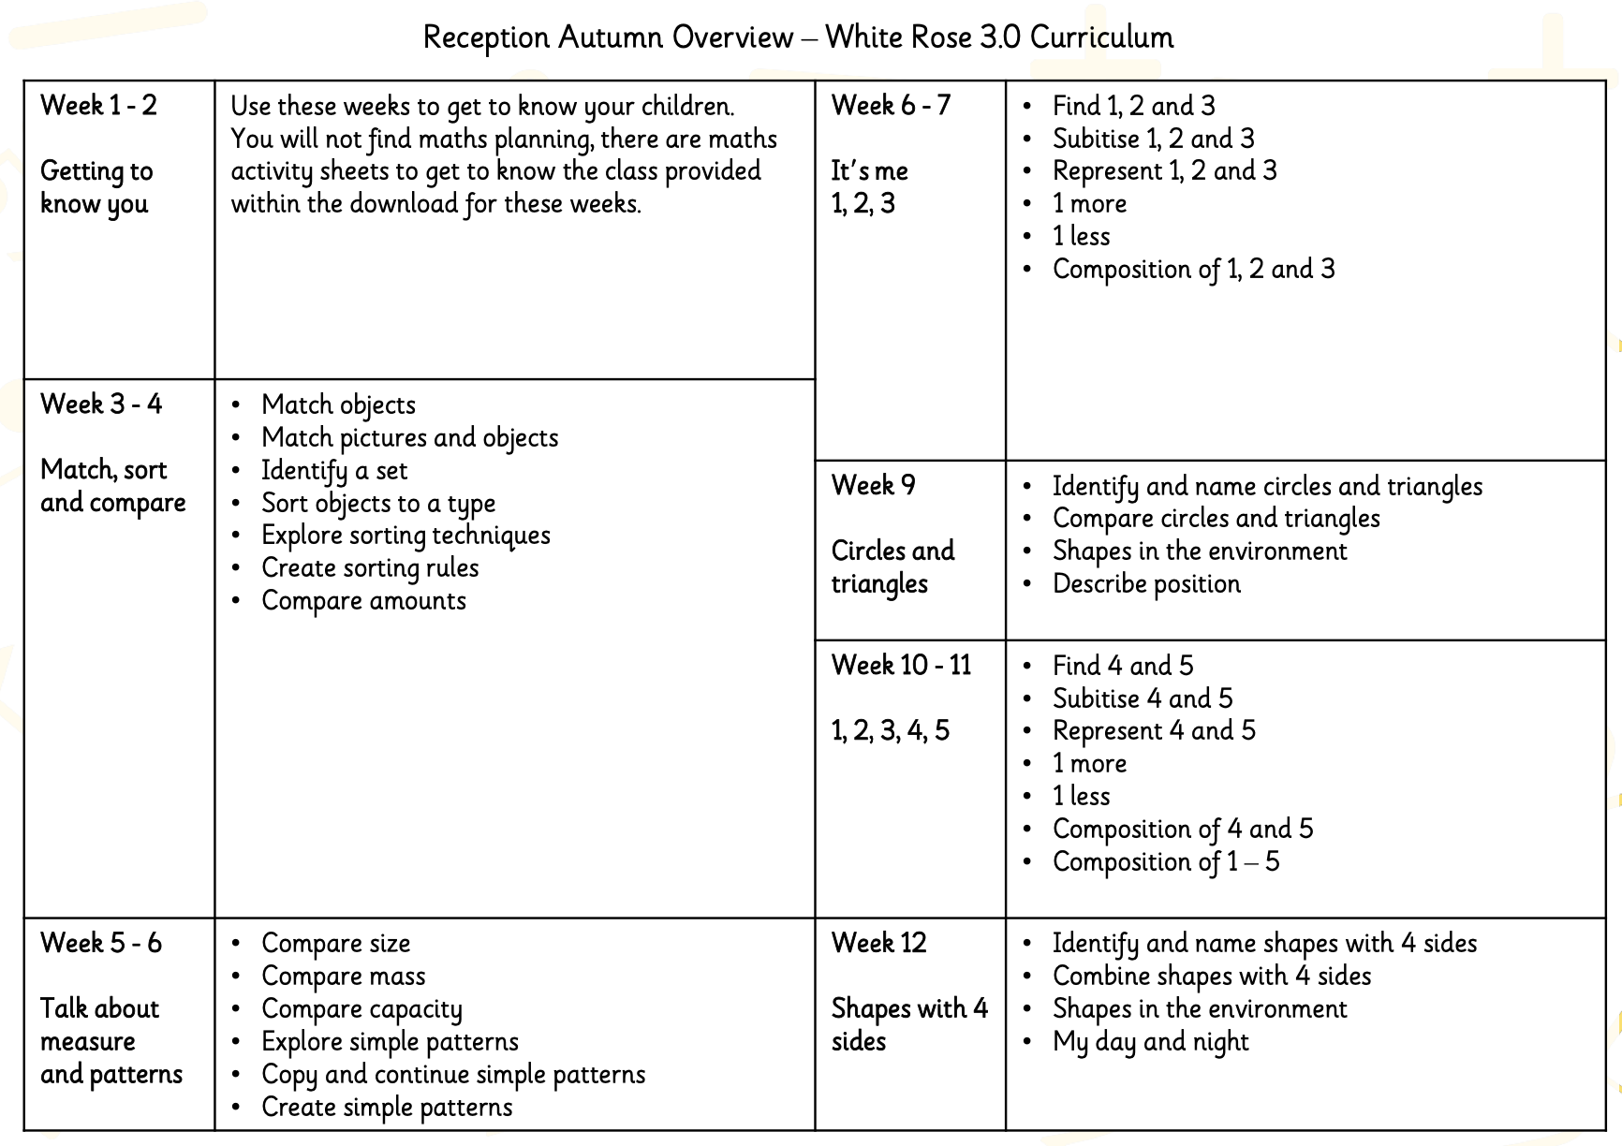
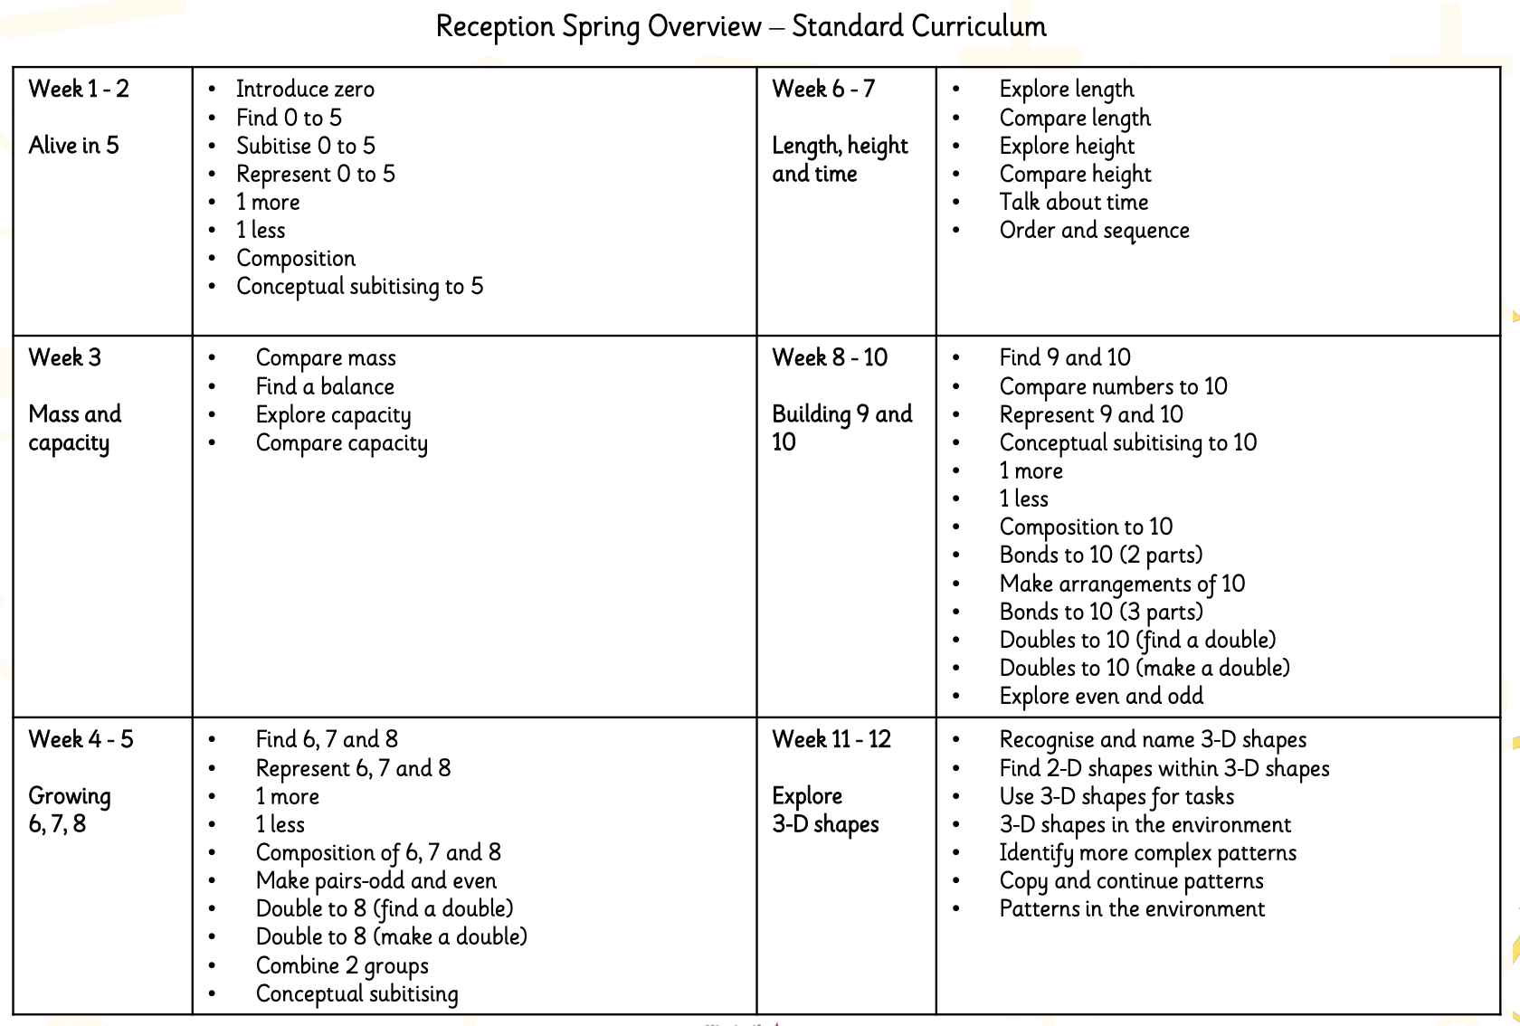
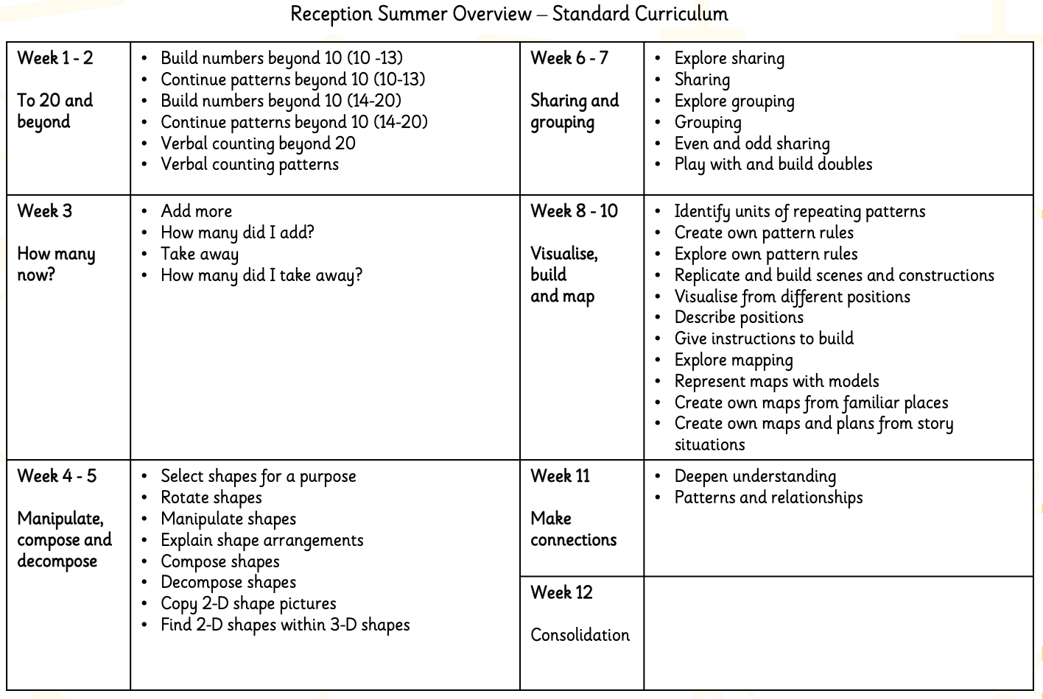

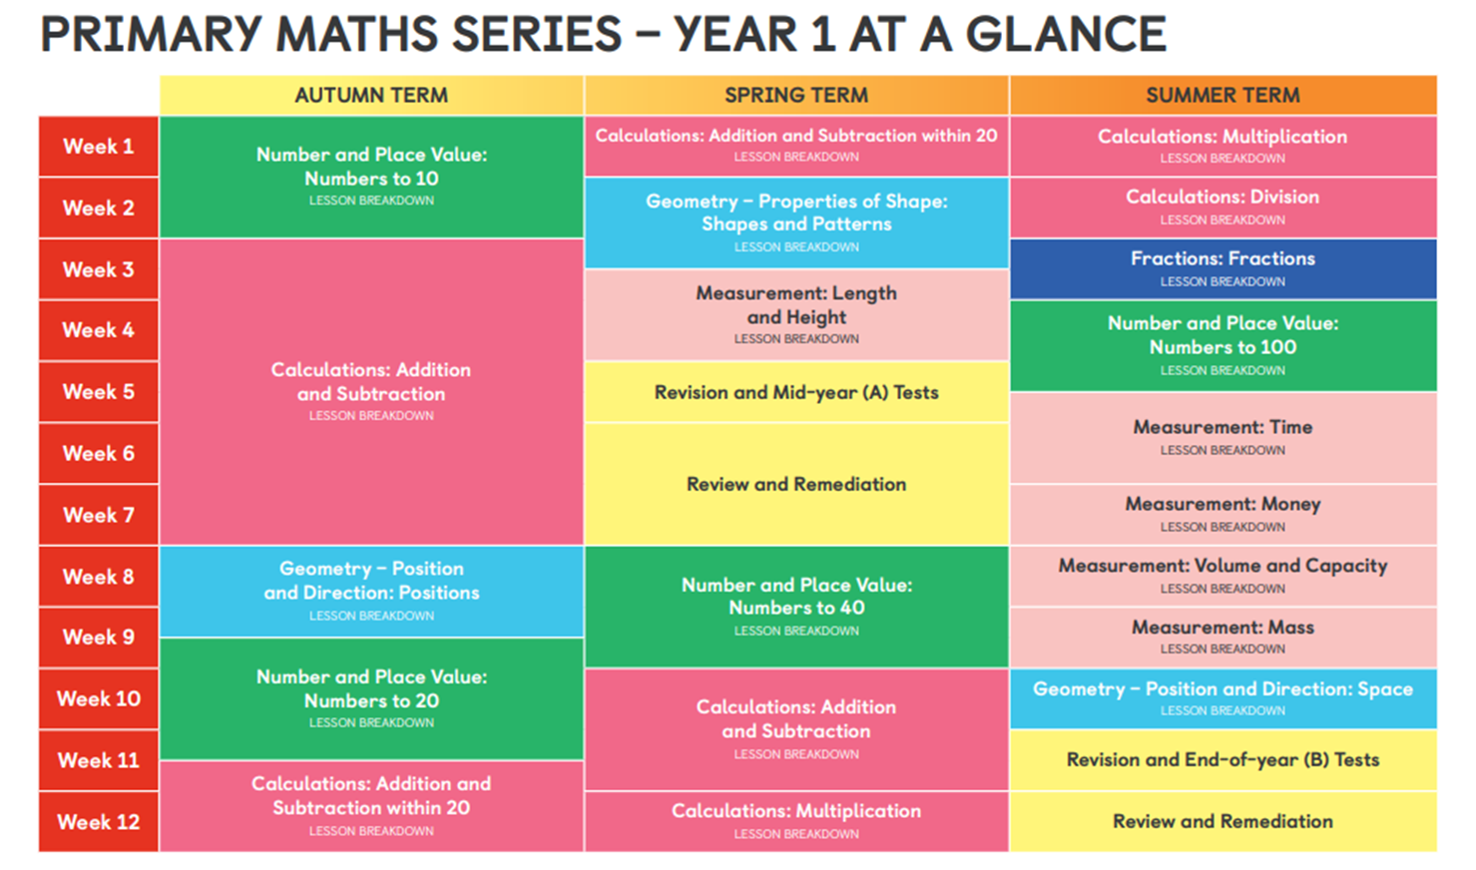

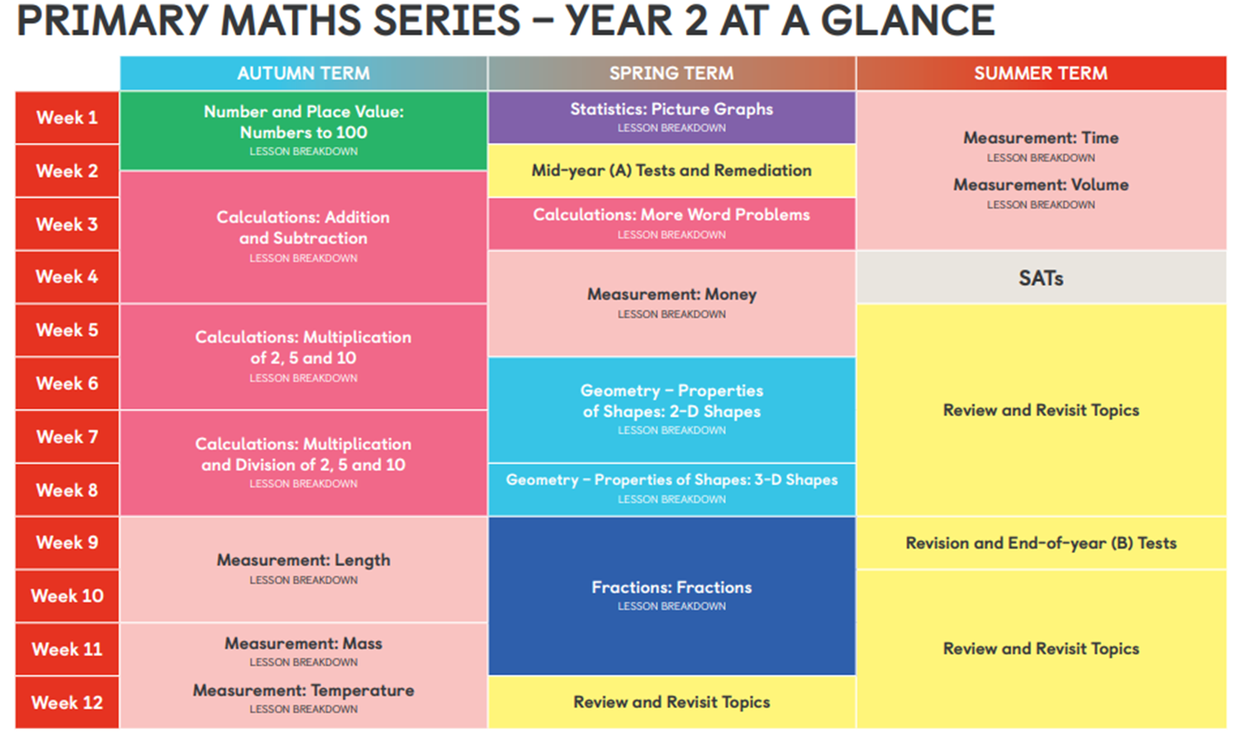

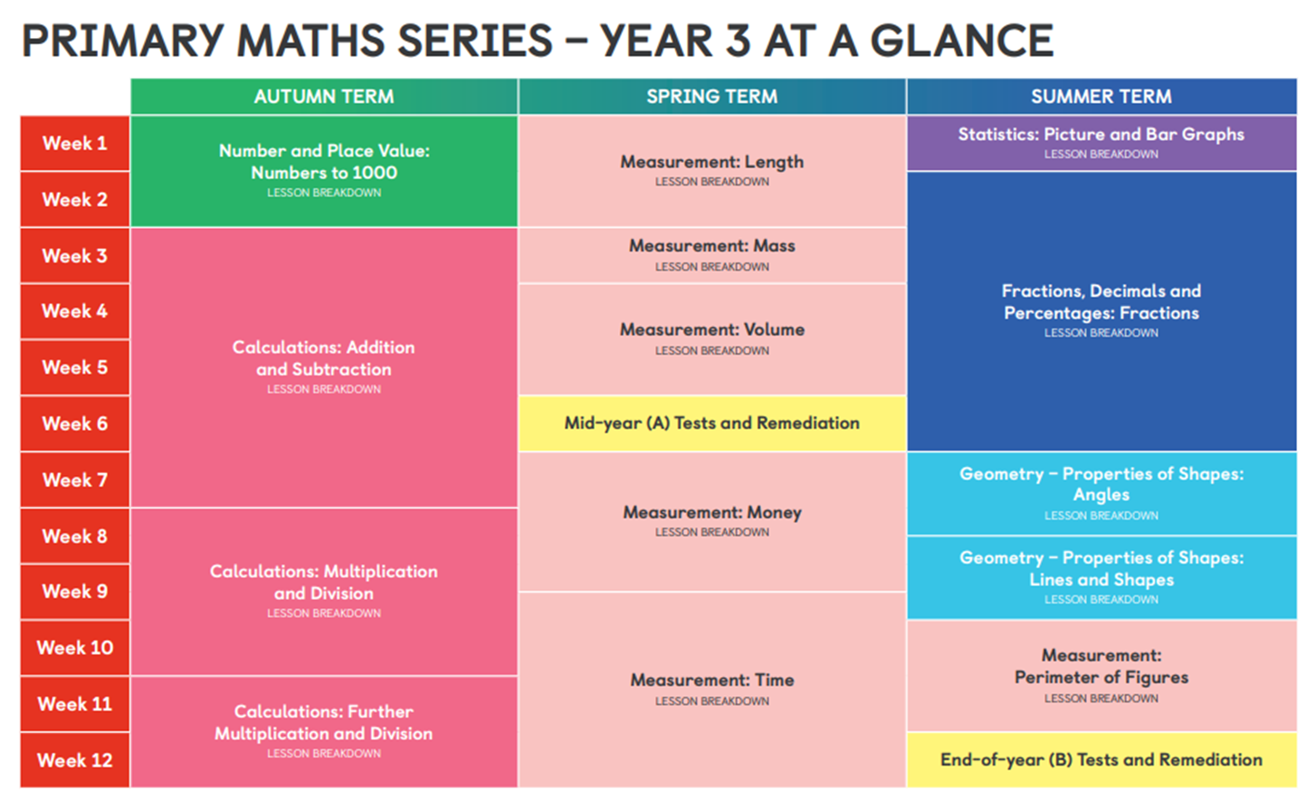

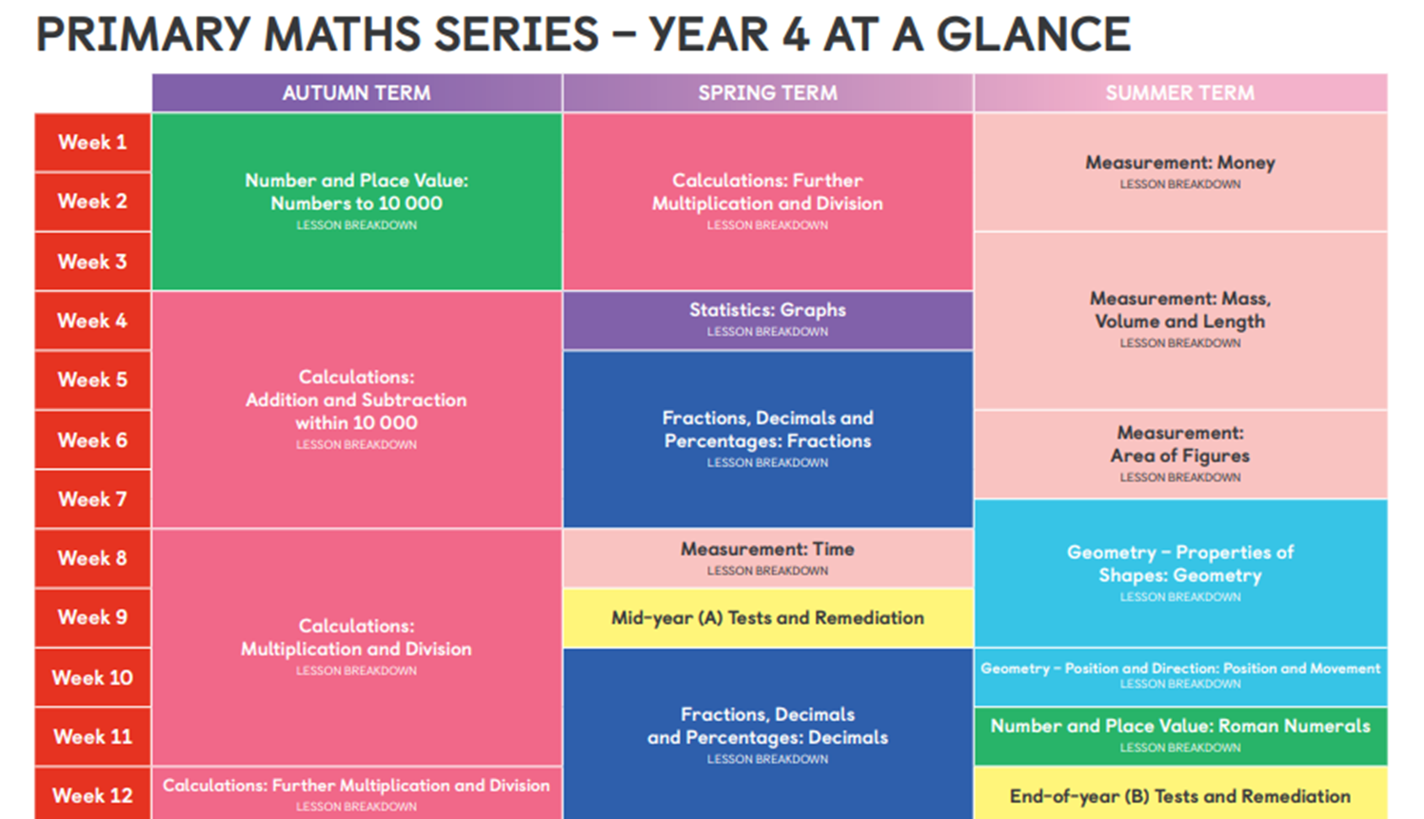

Year 5

Autumn 1 | Place Value | Number: Addition and Subtraction
Autumn 1 | Number 10,000  Round to the nearest 10, 100 and 1000  Number to 100,000  Compare and order numbers to 100,000  Round numbers within 100,000  Number to million  Counting in 10s, 100s, 10,000s and 100,000s  Compare and order numbers to one million  Negative numbers  Roman numerals to 1000 | Add whole numbers with more than 4 digits (column method)  Subtract two 4-digit numbers – more than one exchange  Round to estimate and approximate  Inverse operations (addition and subtraction)  Multi-step addition and subtraction problems
Autumn 2 | Multiplication and division | Fractions
Autumn 2 | Multiples  Factors  Common Factors  Prime Numbers  Square Numbers  Cube numbers  Multiply by 10,100 and 1000  Divide by 10, 100 and 1000 | Equivalent fractions  Fractions greater than 1  Improper fractions to mixed numbers  Mixed numbers to improper fractions  Number sequences  Compare and order fractions less than 1  Compare and order fractions greater than 1  Add and subtract fractions  Add fractions within 1  Add 3 or more fractions  Add fractions Add mixed numbers
Spring 1 | Number: Multiplication and division | Fractions
Spring 1 | Multiply 4 digits by 1 digit  Multiply 2 digits (area model)  Multiply 2 digits by 2 digits  Multiply 3 digits by 2 digits  Multiply 4 digits by 2 digits  Divide 4 digits by 1 digit  Divide with remainders | Subtract fractions  Subtract mixed numbers  Subtract – breaking the whole  Subtract 2 mixed numbers  Multiply unit fractions by an integer  Multiply non-unit fractions by an integer  Multiply mixed numbers by integers  Fraction of an amount  Using fractions as operators
Spring 2 | Decimals and percentages | Measurement: Perimeter & Area |  | Statistics
Spring 2 | Decimals up to 2 d.p.  Decimals as fractions (1)  Decimals as fractions (2)  Understand thousandths  Thousandths as decimals  Rounding decimals  Order and compare decimals  Understand percentages  Percentages as fractions and decimals  Equivalent F.D.P. | Measure Perimeter  Calculate perimeter  Counting square  Area of rectangles  Area of compound shapes  Area of irregular shapes |  | Read and interpret line graphs  Draw line graphs  Use line graphs to solve problems  Read and interpret tables  Two-way tables  Timetables
Summer 1 | Geometry: Properties of Shape | Position & Direction |  | Number: Decimal
Summer 1 | Measure angles in degrees  Measuring with a protractor (1)  Measuring with a protractor (2)  Drawing lines and angles accurately  Calculating angles on a straight line  Calculating angles around a point  Calculating lengths and angles in shapes  Regular and irregular polygons  Reasoning about 3-D shapes | Position in the first quadrant  Translation  Translation with coordinates  Reflection with coordinate |  | Adding decimals within 1  Subtracting decimals within 1  Complements to 1  Adding decimals – crossing the whole  Adding decimals with the same nº of decimal places  Subtracting decimals with the same nº of decimal places  Adding decimals with a different number of decimal places  Subtracting decimals with a different number of decimal places  Adding and subtracting wholes and decimals  Decimal sequences  Multiplying decimals by 10, 100 and 1,000  Dividing decimals by 10, 100 and 1,000
Summer 2 | Negative Numbers | Geometry: Converting Units |  | Geometry: Volume
Summer 2 |  | Kilometres  Kilograms and kilometres  Millimetres and millilitres  Metric units Imperial units  Converting units of time  Timetables |  | What is volume?  Compare volume  Estimate volume  Estimate capacity
Year 6
Autumn 1 | Place Value |  | Calculate using 4 operations |  | Number Facts
Autumn 1 | Read, write, order and compare numbers to 10 million  Multiply and divide integers and decimals by 10, 100 and 1000.  Solve word problems by multiplying and dividing by 10, 100 and 1000  Convert between main units of g & KG  Round a set of numbers, including decimals up to thousandths  Explain about powers of 10  Order and compare integers, decimals and negatives  Find the difference between positive and negative integers |  | Written formal addition (showing awareness of mental or formal method)  Calculate addition pairs mentally (strategy of 10.9.9.9)  Multiply and divide numbers mentally (Related multiplication facts)  Use all four operations mentally efficiently  Add and subtract integers and decimals using the formal method  Multiply using the formal efficient method  Learn the formal efficient methods of division  Solve word problems using all four operations efficiently  Apply knowledge of addition (cryptarithms) |  | Recognise number sequences involving place value knowledge  Investigate rules of divisibility  Identify prime numbers less than 100; find the prime factors of two-digit numbers  Problem solve using factors of numbers using letters of the alphabet  Problem solve using prime factors knowledge using letters of the alphabet
Autumn 2 | Properties of 2d & 3d shapes |  | Handling Data- |  | Efficient Calculating methods
Autumn 2 | Describe quadrilaterals using their properties  Understand diagonals in quadrilaterals  Draw nets with increasing accuracy  Draw 3d shapes accurately using isometric grids  Use a protractor to construct triangles  Use a protractor to present data  Represent and interpret linear sequences with missing numbers  Calculate area and perimeter of complex rectilinear shapes  Apply knowledge of area and perimeter  Prove the formula for the area of triangles and parallelograms  Find the Area of triangles and parallelograms  Complete reflection of complex shapes |  | Create a line graph from own data collected, understanding continuous data  Read and analyse information from a line graph.  Construct and interpret combination bar charts  Interpret pie charts  Construct pie charts  Complex bar line graphs  Solve problems using a conversion graph  Convert standard units of measures (litres)  Convert mm to cm, m and km and vice versa  Scale quantities up or down  Read and interpret measuring scales  Use data to find averages |  | Accurately calculate mentally with integers and decimals  Add and subtract formally integers and decimals  Multiply and divide formally integers & decimals  Solve problems involving multi-step calculation using brackets
Spring 1 | Fractions, Decimals & Percentages |  | Fractions, Decimals & Percentages (Part 2) |  | Operations
Spring 1 | LO: To find fractions of a number  LO: To find percentages of a number  Calculate the perimeter of rectilinear shapes; estimate the perimeter of an irregular shape  Calculate the area of rectilinear shapes; estimate the area of an irregular shape  Calculate the perimeter and area of irregular shapes;  Use the formula to calculate the area of triangles and parallelograms  Find the highest common factor  LO: To find the lowest common multiple  Use knowledge of equivalent fractions (to be able to order them.)  Convert improper and mixed number fractions  Calculate fractions of shapes, amounts and quantities  Add together 2 fractions  Subtract two fractions  Multiply two fractions  Divide using a fraction  Find percentages of amounts  Count in fraction steps  Prove calculations with fractions |  | Multiply using a factor method  To choose efficient written methods to subtract integers and decimals  Use a formal written method to multiply integers and decimals  Solve problems involving multi-step calculations explaining method  Prove equivalence between fractions, decimals and percentage in diff contexts  Use equivalences between f,d,p, including different contexts  Associate a fraction with division and calculate decimal fraction equivalents for a simple fraction  Order fractions by converting to decimals  Complete missing number sequences inc decimals  Order numbers and complete inequalities  Round numbers of decimals up to 3 places  Solve problems involving missing fraction quantities  To apply knowledge of fractions, decimals and percentages  Find missing values linked to percentages  Find related multiplication and division facts involving decimals |  | Recall square numbers, square roots and cubed numbers  Identify prime numbers less than 100; find the prime factors of two-digit numbers  Show understanding of related factors and multiples  Test rules of divisibility to estimate and check results of missing number calculations  Understand order of operations  Calculate Knowledge of order of operations
Spring 2 | Properties and classifying 2d & 3d shapes |  | Pie charts & Conversions |  | Ratio & Averages
Spring 2 | Describe, identify and visualise 2d shapes & 3d solids  Construct 2D shapes using a protractor and set square  Use the properties of a circle  Solve area and perimeter problems  Find the volume of cubes and cuboids  Find the surface area of cubes and cuboids |  | Draw a conversion graph  Read and interpret scales on a range of measuring instruments  Investigate a range of measures problems  Interpret pie charts  Construct pie charts |  | Understand the concept of ratio  Use ratio to solve basic problems  Solve problems, using the mean  Use bar charts to find the mode, median, mean and range  Solve problems involving ratio  Solve formula questions  Calculate mentally with integers and decimals  Efficient written methods to multiply integers and decimals  Calculate money word problems using trial and improvement  Record remainders as fractions, decimals or rounding  Convert fractions to decimals  Solve problems involving consecutive numbers
Summer 1 | Algebra |  | Coordinates, Reflections, Translations |  | Revision
Summer 1 | Find a rule – one step  Find a rule – two step  Forming Expressions  Substitution  Using formulas  Forming equations  Solving one step equations  Solving two step equations  Find pairs of values with pictorial representation  Find pairs of values |  | Recognise parallel and perpendicular lines in 2D shapes.  Calculate angles in regular polygons and on a straight line  Estimate, measure and draw angles using a protractor  Translate shapes using coordinates  Reflect shapes around mirror lines including diagonals  Solve ratio and proportion problems involving shapes  Solve simple problems involving ratio and proportion  Solve complex problems involving ratio and proportion  Calculate the area and perimeters of a rectangle and triangles |  | Factors, Multiples & Prime Numbers  Calculate using multiplication  Translation  To calculate Area & perimeter of polygons  Properties of triangles  Mean  Negatives  Estimate decimals and fractions on a number line  To calculate money word problems  Calculate angles on a straight line & polygons, and at a point  Measures word problems  Mixed number fractions  Simplifying & equivalent fractions  Converting fractions to decimals  Addition & Subtraction of fractions  Recap parts of a circle  Identify missing multiple  Division Strategies (Paper method)  Percentages of amounts  Estimate, measure & draw angles  Properties of quadrilaterals  Reflect and translate shapes using coordinates  Solving algebraic formulas  Roman Numerals  Calculating with fractions  Convert % to fractions & vice versa  Time problems (including timetables)  Creating pie charts  Find fractions of amounts  To answer questions about graphs & tables  Identify the nets of 3D shapes  Equations with 2 unknowns  Identify missing multiples  Recap over ratio and proportion
Summer 2 | Transition maths to prepare for KS3
Summer 2 | Rounding using significant figures  Calculate mean, mode, range & median  Read and write algebra  Substituting into a formula  Simplifying expressions  Solving equations  Identifying correlation on scatter graphs  Calculate area and perimeter of complex shapes  Calculate the volume and surface area of cuboids  Isometric 3d drawings  Budgeting

